**ASSIGNMENT -5 (ADVANCED PROGRAMMING)**

**Paaras Dev– 22BCS11495**

1. **Problem 1:** Find the Difference.
2. **Implementation/Code:**

class Solution {

public char findTheDifference(String s, String t) {

int ssum = 0;

int tsum =0;

for(int i=0;i<s.length();i++)

{ssum = ssum + (int)s.charAt(i); }

for(int i=0;i<t.length();i++) {

tsum = tsum + (int)t.charAt(i); }

int value = tsum - ssum;

return (char)value;

}}

1. **Output:**

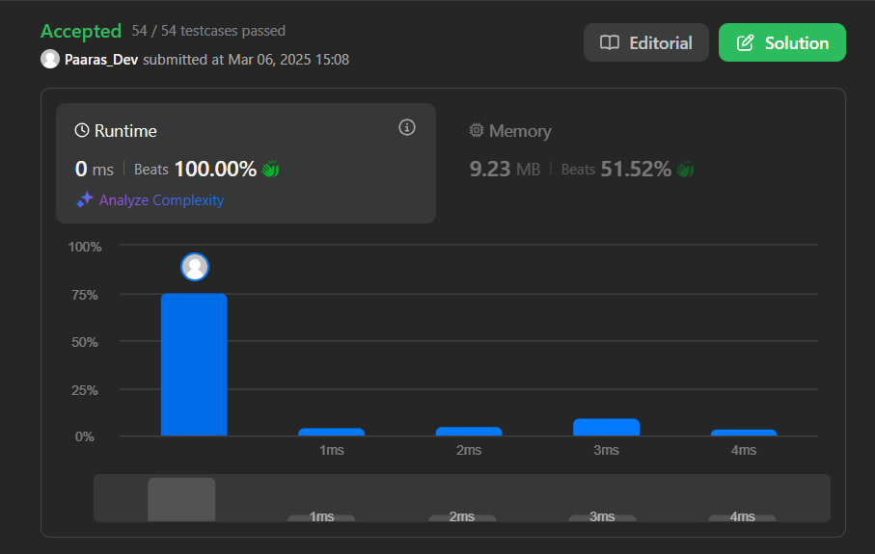

1. **Problem 2:** Largest Perimeter Triangle
2. **Implementation/Code:**

class Solution {

public int largestPerimeter(int[] nums) {

Arrays.sort(nums);

for(int i = nums.length-1; i>1; i--){

if(nums[i] < nums[i-1] + nums[i-2])

return nums[i] + nums[i-1]+ nums[i-2];

}

return 0;

}

}

1. **Output:**



1. **Problem 3:** Third Maximum Number
2. **Implementation/code:**

class Solution {

public int thirdMax(int[] nums) {

Integer max1 = null;

Integer max2 = null;

Integer max3 = null;

for (Integer n : nums) {

if (n.equals(max1) || n.equals(max2) || n.equals(max3)) continue;

if (max1 == null || n > max1) {

max3 = max2;

max2 = max1;

max1 = n;

} else if (max2 == null || n > max2) {

max3 = max2;

max2 = n;

} else if (max3 == null || n > max3) {

max3 = n; } }

return max3 == null ? max1 : max3; }}

1. **Output:**



1. **Problem 4:** Sort Characters By Frequency
2. **Implementation/code:**

import java.util.*;

class Solution {

public String frequencySort(String s) {

Map<Character, Integer> frequencyMap = new HashMap<>();

for (char c : s.toCharArray()) {

frequencyMap.put(c, frequencyMap.getOrDefault(c, 0) + 1); }

PriorityQueue<Character> maxHeap = new PriorityQueue<>(

(a, b) -> frequencyMap.get(b) - frequencyMap.get(a) );

maxHeap.addAll(frequencyMap.keySet());

StringBuilder result = new StringBuilder();

while (!maxHeap.isEmpty()) {

char c = maxHeap.poll();

result.append(String.valueOf(c).repeat(frequencyMap.get(c))); }

return result.toString();

}}

1. **Output:**



1. **Problem 5:** Minimum Number of Arrows to Burst Balloons
2. **Implementation/Code:**

class Solution {

public int findMinArrowShots(int[][] segments) {

Arrays.sort(segments, (a, b) -> Integer.compare(a[1], b[1]));

int ans = 0, arrow = 0;

for (int i = 0; i < segments.length; i ++) {

if (ans == 0 || segments[i][0] > arrow) {

ans ++;

arrow = segments[i][1];

}

}

return ans;

}

}

1. **Output:**



1. **Problem 6:** Boats to Save People
2. **Implementation/Code:**

import java.util.Arrays;

class Solution {

public int numRescueBoats(int[] people, int limit) {

Arrays.sort(people);

int left = 0, right = people.length - 1;

int boats = 0;

while (left <= right) {

if (people[left] + people[right] <= limit) {

left++;

}

right--;

boats++; }

return boats; }}

1. **Output:**



1. **Problem 7:** K Closest Points to Origin
2. **Implementation/Code:**

class Solution {

public int[][] kClosest(int[][] points, int k) {

PriorityQueue<int[]> maxHeap = new PriorityQueue<>(

(a, b) -> Integer.compare((b[0] * b[0] + b[1] * b[1]), (a[0] * a[0] + a[1] * a[1])) );

for (int[] point : points) {

maxHeap.add(point);

if (maxHeap.size() > k) {

maxHeap.poll(); } }

int[][] result = new int[k][2];

for (int i = 0; i < k; i++) {

result[i] = maxHeap.poll(); }

return result; }}

1. **Output:**



1. **Problem 8:** Reduce Array Size to The Half
2. **Implementation/Code:**

import java.util.*;

class Solution {

public int minSetSize(int[] arr) {

Map<Integer, Integer> freq = new HashMap<>();

for (int num : arr) freq.put(num, freq.getOrDefault(num, 0) + 1);

List<Integer> counts = new ArrayList<>(freq.values());

counts.sort(Collections.reverseOrder());

int res = 0, cnt = 0, half = arr.length / 2;

for (int num : counts) {

cnt += num;

res++;

if (cnt >= half) break; }

return res; }}

1. **Output:**

